Name: _________________________________________________________________ Core: ________
Force and Motion Test Review

Motion:
1) What is a reference point?
A non-moving point from which motion is measured
2) If you are sitting in a parked car, and the car next to you pulls forward, what direction does it appear that your car is moving?
Your car appears to be moving backward, even though it is actually stationary

3) How do you calculate speed? How do you calculate distance?
Speed = distance / time Distance = speed x time
How do you calculate time?
Time = distance / speed
4) What is the difference between speed and velocity?
Velocity includes direction
5) What is acceleration?
The rate of change of velocity (how quickly does the velocity change)
How do you calculate it?
Acceleration = final velocity – starting velocity
time
Motion graphs:
6) Distance vs. Time: A line moving upward means
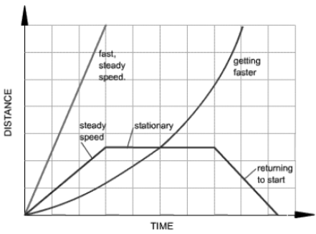
Constant speed
A steeper line means
Faster speed
A horizontal (flat) line means
Not moving
A downward sloping line means
Returning to start (decreasing distance)
A curved upward line means
Getting faster (accelerating)
0 means At the start
To calculate speed from a graph, you would:
Find a point on the line – look at the distance on the y axis and the matching time on the x axis. Then divide the distance by the time.
7) Speed vs. Time Graph:

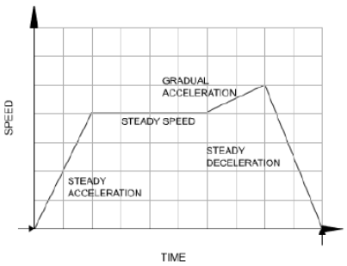
An upward sloping line means
Speeding up (acceleration)
A steeper line means
Faster acceleration
A horizontal (flat) line means
A steady speed
A downward sloping line means
Deceleration
0 means
Not moving

Balanced and Unbalanced Forces:
8) What is a force?
A push or pull on an object that changes the motion of the object
9) What are balanced forces?
When the forces on an object have a net force of 0. Do not change the motion of a moving object, or make a nonmoving object start moving
10) What are unbalanced forces?
Net forces do not equal 0, DO cause a change in object’s motion
11) What is net force?
Combination of all forces acting on an object
12) If a force is put on an object and it doesn’t move, what kind of force must also be pushing on the object?
A balanced force
13) What kind of force must be on an object for it to move?
Am unbalanced force
14) What types of unbalanced forces cause moving objects to slow or stop moving? Friction
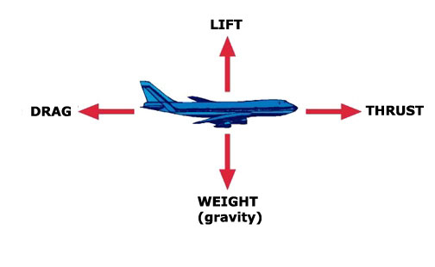
15) For a plane to lift up into the air, which force must overcome which other force? Lift must overcome gravity
16) For a plane to move forward, which force must overcome which other force? Thrust must overcome drag
17) Drag is another name for what unbalanced force?
Air Resistance

Balanced and Unbalanced Force Calculations:
(To jog your memory…)
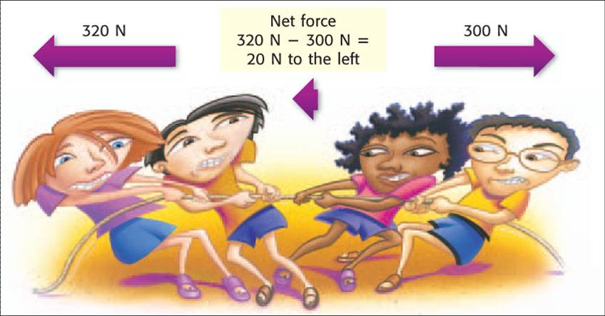
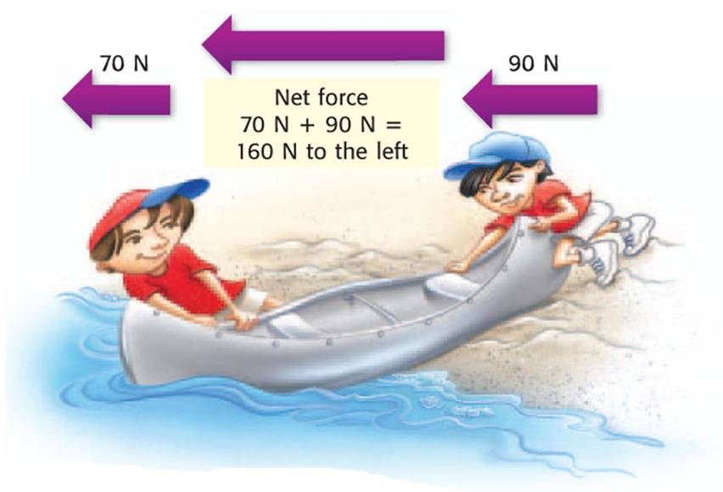

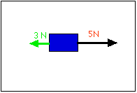
18) In which direction, and with how much force will the blue box move?
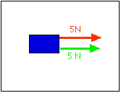
1.
2.

5 N + 5 N = 10 Newtons to the right 5 N – 3 N = 2 Newtons to the right

19) In what direction, and with how much force is the car traveling?
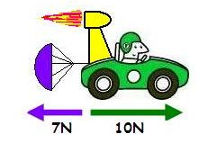

10 N – 7 N = 3 Newtons to the right

Newton’s Laws:
20) Which of Newton’s Laws are the following examples of?
A rocket takes off from the ground – Newton’s 3rd Law
A book slides forward on a seat when the car stops – Newton’s 1st Law
A golf ball sits on a tee – Newton’s 1st Law
A balloon is propelled across the room when the air is released – Newton’s 3rd Law
A full shopping cart does not accelerate as quickly as an empty one – Newton’s 2nd Law

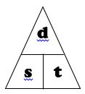
Calculations:
21) Know how to calculate: (Remember your magic triangles!)
speed / distance / time
speed = distance / time
time = distance / speed
distance = speed x time

Acceleration (vs. time)
Acceleration = final velocity – starting velocity
time
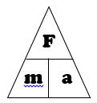

acceleration / force / mass
acceleration = force / mass
force = mass x acceleration
mass = force / acceleration

Gravity and Air Resistance:
22) How can you slow down the effect of gravity on a falling object?
Increase air resistance
23) What is terminal velocity?
The constant velocity of a falling object when the force of air resistance equals the force of gravity
24) What is the difference between mass and weight?
Mass is the amount of matter in an object. Weight is how much gravity pulls on the object’s mass
25) What is air resistance?
The force acting opposite the object’s motion, slows objects down
26) What effect does friction have on a moving object?
Slows objects down

27) To row a boat forward, you have to overcome friction and air resistance. What will help the most at being to overcome those unbalanced forces? (Hint, think about the pictures below!)
Increase the force to move the boat forward by increasing the number of rowers
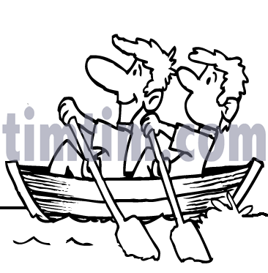
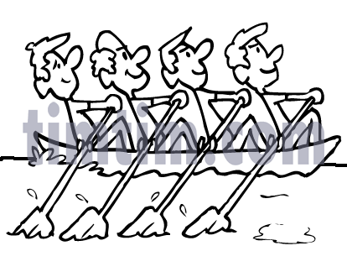

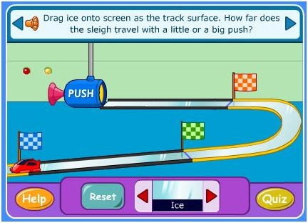
28) Why does the truck travel so much farther on the ice than on the vinyl? What effect does friction have on the truck in the pictures below? What would happen to the truck if there was NO friction?
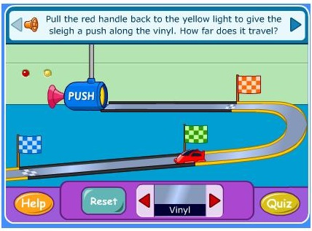
Ice has very little friction, while the vinyl has more. The friction on the vinyl slows the truck down. If there was no friction at all, the truck would continue to move forever until some other force stopped it.

