Name: _____________________________________________

Amoeba Coloring
The amoeba is a protist that belongs to the Kingdom Protista. The name amoeba comes from the Greek word amoibe, which means change. Protists are microscopic unicellular organisms that don't fit into the other kingdoms. Some protozoans are considered plant-like while others are considered animal-like. The amoeba is considered an animal-like protist because it moves and consumes its food. Protists are classified by how they move. Some have cilia or flagella, but the amoeba has an unusual way of creeping along by stretching its cytoplasm into fingerlike extensions called pseudopods. (The word "pseudopod" means "false foot".) On the coloring sheet, there are several pseudopods. Color the pseudopods yellow. When you look at an amoeba under a microscope, no amoeba looks the same as any other. The cell membrane is very flexible and allows the amoeba to change shape. Color the cell membrane red. Amoebas live in ponds or puddles, and can even live inside people.
There are two types of cytoplasm in the amoeba, the darker cytoplasm toward the interior of the protozoan is called endoplasm, and the clearer cytoplasm that is found near the cell membrane is called ectoplasm. (On the coloring, the endoplasm is indicated by the dotted area, and the ectoplasm by the white area.) Color the endoplasm blue, and leave the ectoplasm uncolored. By pushing the endoplasm toward the cell membrane, the amoeba causes its body to extend and creep along. It is also by this method that the amoeba consumes its food. The pseudopods extend out and wrap around a food particle in a process call phagocytosis. The engulfed food then becomes a food vacuole. There are several food vacuoles on the drawing. Color each food vacuole brown. The food will eventually be digested by the cell’s lysosomes.
Also visible in the amoeba is the nucleus, which contains the amoeba's DNA. Color the nucleus purple. In order to reproduce the amoeba goes through mitosis, where the nucleus duplicates its genetic material and the cytoplasm splits into two new daughter cells, each identical to the original parent. This method of reproduction is called binary fission. Another structure easily seen in the amoeba is the contractile vacuole, whose job is to pump out excess water so that the amoeba does not burst. Color the contractile vacuole orange.
During unfavorable conditions, the amoeba can create a cyst. This hard-walled body can exist for a long period of time until conditions become favorable again. At this point it opens up and the amoeba emerges. Often cysts are created during cold or dry periods where the amoeba couldn’t survive in its normal condition. Color the cyst green.
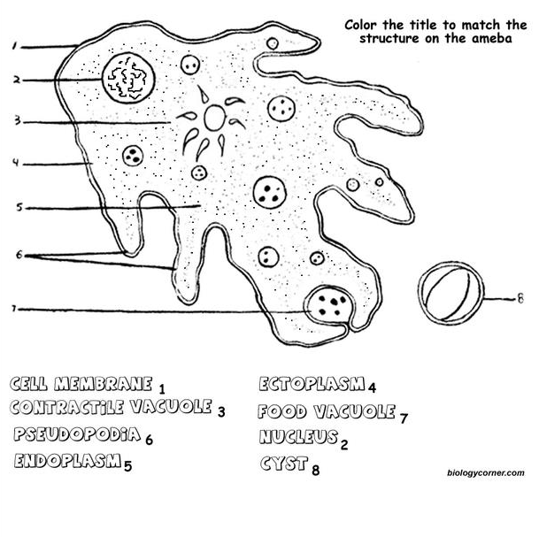
Amoebas can cause disease. A common disease caused by the amoeba is called Amoebic Dysentery. A person becomes infected by drinking contaminated water. The amoeba then upsets the person's digestive system and causes cramps and diarrhea. A person is most likely to be infected in countries where the water is not filtered or purified.
Questions:
1. How does an amoeba move?
2. What structure contains the amoeba's DNA?
3. How does an amoeba reproduce?
4. During unfavorable conditions, an amoeba
forms a ... ?
5. Fingerlike extensions of the amoeba's cytoplasm are called ...?
6. What disease is caused by the amoeba?

