Names: _____________________________________________________ Core: _________
Lab Equipment Practical

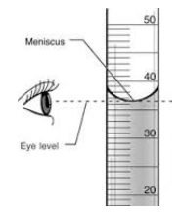
Station 1 – Measuring Volume
Materials:
100 mL Graduated cylinder
1000 mL beaker
250 mL beaker
250 mL Erlenmeyer flask

Task:
1) From the 1000 mL glass beaker, pour 50 mL of water into the 250 mL beaker.
2) Pour the water from the 250 mL beaker into the 100 mL graduated cylinder.
3) Measuring to the bottom of the meniscus in the graduated cylinder, what is the actual amount of water you had in your beaker? _______________________ mL
4) Repeat Steps 1 and 2 using the 250 mL Erlenmeyer flask.
5) Measuring to the bottom of the meniscus in the graduated cylinder, what is the actual amount of water you had in your flask? ____________________________ mL
6) Repeat Steps 1 and 2 using the 100 mL graduated cylinder.
7) Measuring to the bottom of the meniscus in the graduated cylinder, what is the actual amount of water you had in the graduated cylinder? ____________________________ mL
8) Which gave you the most accurate results?__________________________ Why? _____________________
__________________________________________________________________________________________
9) Why would we sometimes need exact measurements? ___________________________________________
__________________________________________________________________________________________
10) When would we use beakers and Erlenmeyer flasks? ____________________________________________
__________________________________________________________________________________________

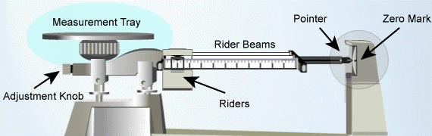
Station 2 – Measuring Mass
Materials:
Triple beam balance
Metal washers, assorted sizes

Task:
1) Zero the triple beam balance. (To do this, slide all three riders to the left on the rider beams, and make sure the pointer is at the zero mark. If it is not, turn the adjustment knob either clockwise or counter clockwise until the pointer is at the line.)
2) Place one large metal washer and two medium metal washers on the measurement tray. What is the mass of the three washers in grams? ____________________________g
3) Remove the large washer from the measurement tray. What is the mass of just the two medium washers? ___________________________ g
4) Calculate the mass in of the large washer by subtracting your answer in #3 from your answer in #2. Write your answer here: _________________________g
5) Place just the large washer on the measurement tray. What does the triple beam balance measure the one washer to be? _______________________ g
6) Is there a difference in the two answers? Why or why not? ________________________________________
__________________________________________________________________________________________
7) Place 4 medium washers on the measurement tray. What is the mass of all 4 washers? _________________ g
8) Divide your answer in #7 by 4. What is the average mass of one washer? __________________________ g
9) Remove all but one medium washer. What does the the triple beam balance measure the one washer to be? _______________________ g
10) Is there a difference in the two answers? Why or why not? _______________________________________
__________________________________________________________________________________________

Station 3 – Measuring Temperature
Materials:

6 Thermometers 2 Beakers

Task:
1) Using the sink, fill one beaker with hot water, and one with cold.
2) Place one thermometer in each beaker.
3) Wait 1 minute, and record the temperature: _____________________________ ºF (hot water)
_____________________________ ºF (cold water)
4) Remove the thermometers and lay them on the table for 2 minutes.
5) Look at the other 4 thermometers without picking them up. What temperature do you see? _____________ºF
6) Have each lab group member pick up and hold one of the other four thermometers in their hand with their thumb over the red bulb at the bottom. Wait until the “mercury” stops moving. What are the new temperatures? __________________ ºF __________________ ºF __________________ ºF __________________ ºF
7) Look back at the first two thermometers. After “resting” for two minutes, what are the new temperatures?
_____________________________ ºF (hot water) _____________________________ ºF (cold water)

Station 4 – Measuring Volume, Part 2
Materials:

1000 mL beaker 10 mL graduated cylinder 100 mL graduated cylinder

Task:
1) Using the sink, measure 10 mL of water into the 10 mL graduated cylinder. Pour the water into the 1000 mL beaker.
2) How full does the beaker appear to be? ________________________________________________________
3) Repeat step 1 ten more times.
4) How full does the beaker appear to be? ________________________________________________________
5) Using the sink, measure 100 mL of water into the 100 mL graduated cylinder. Pour the water into the 1000 mL beaker.
6) How full does the beaker appear to be? ________________________________________________________
7) Repeat step 5 five more times.
8) How full does the beaker appear to be? ________________________________________________________
9) When would be a good time to use a 10 mL graduated cylinder? ____________________________________
__________________________________________________________________________________________
10) When would be a good time to use a 100 mL graduated cylinder? __________________________________
__________________________________________________________________________________________

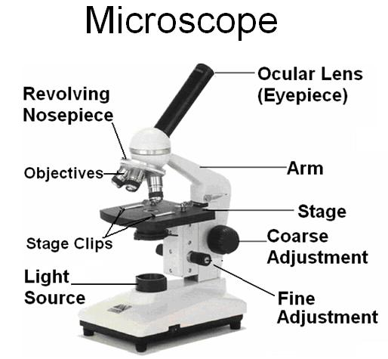
Station 5 – Using a Microscope
Materials:

Microscope letter “e” slide

Task:
1) Adjust the microscope so the scanning objective (the shortest lens) is set for viewing. Place the letter “e” slide onto the microscope’s stage so the label is to the left.
2) Using the coarse and fine adjustment knobs, get the letter “e” into focus. Let everyone have a chance to look through the eyepiece. Draw a picture of what you see in the left circle below.
3) Turn the nosepiece so the 100x objective (the medium lens) is set for viewing. Using the fine adjustment knob, get the letter “e” into focus. Let everyone have a chance to look through the eyepiece. Draw a picture of what you see in the right circle below.

4) Do you always need to use the highest powered objective to view specimens through the microscope? Why or why not? _______________________________________________________________________________
__________________________________________________________________________________________
5) What does the position of the letter “e” tell you about the images you see through the microscope? ________
__________________________________________________________________________________________

Station 6 – Using an Eye Dropper
Materials:

4 Eye droppers 4 eye dropper bottles with water 4 pennies paper towels

Task:
1) Using the eye dropper and the eye dropper bottles, have each person in the group place a drop of water on a penny.
2) Continue placing drops of water on the penny, counting each drop. See how many drops can be placed on each penny until the water spills over and off the penny.
3) Record the number of drops each person was able to place on the penny.
Penny 1 _____________________ drops Penny 2 _____________________ drops
Penny 3 _____________________ drops Penny 4 _____________________ drops
4) Repeat Steps 1 – 3. Record the second trial below.
Penny 1 _____________________ drops Penny 2 _____________________ drops
Penny 3 _____________________ drops Penny 4 _____________________ drops
5) Are you able to control the size of the drop from the dropper? If so, how? ____________________________
__________________________________________________________________________________________
6) Why were different people able to get different results? ___________________________________________
__________________________________________________________________________________________

